**HTML 5 – ASSIGNMENT**

**1. What are the new tags added in HTML5?**

* New tags added in HTML5 is Header, Footer, Section, Article, NAV, Mark, Main etc.

**Ex:-**

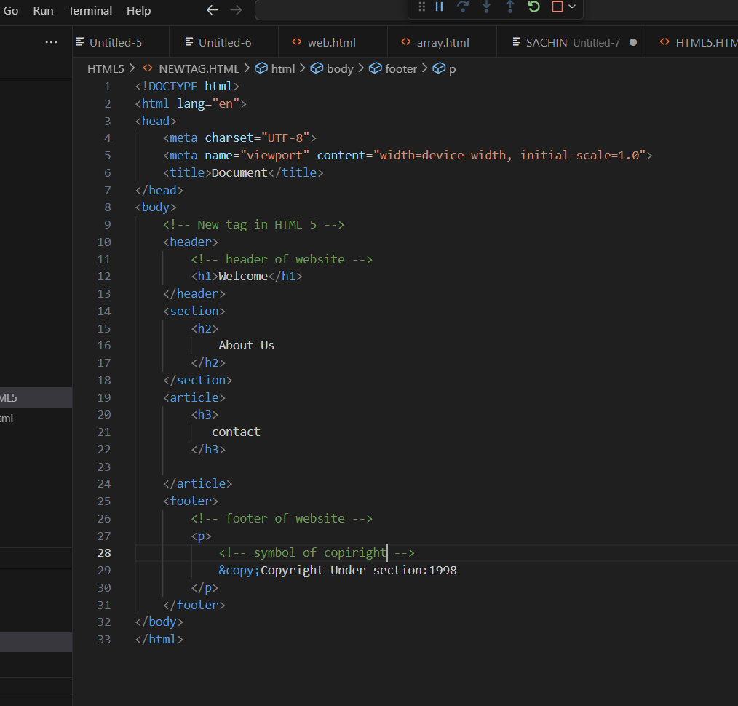

**Output:-**

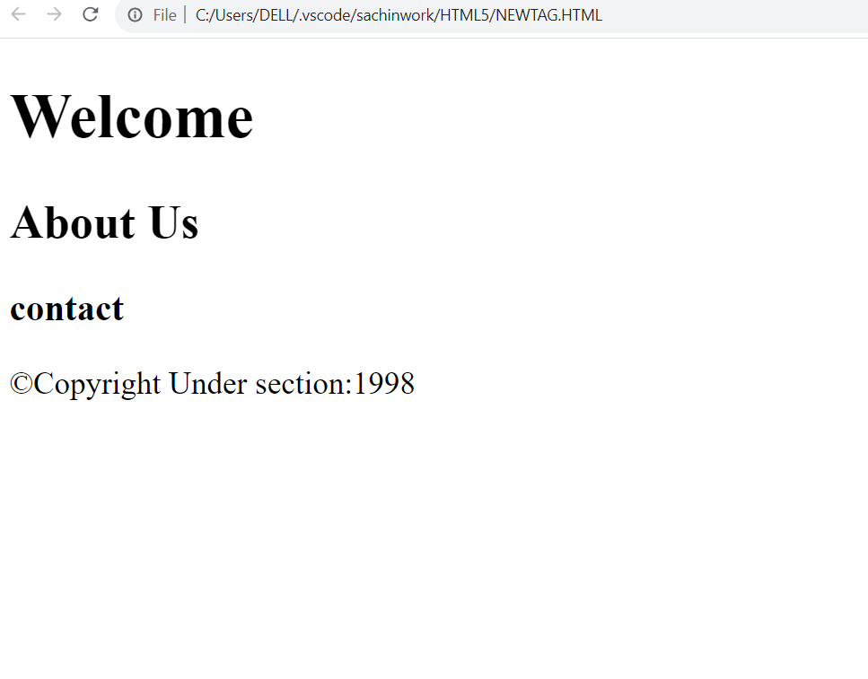

**2. How to embed audio and video in a webpage?**

* The HTML <video> element is used to show a video in webpage.
* The HTML <audio> element is used to show an audio in webpage.

**Ex:-**

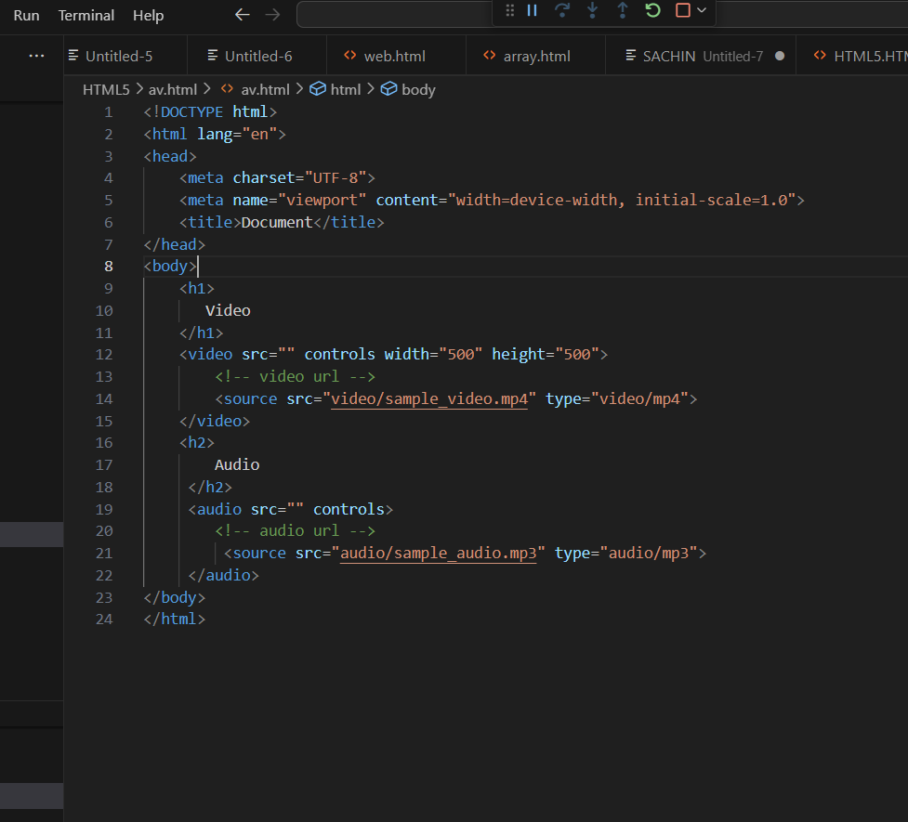

Output:-

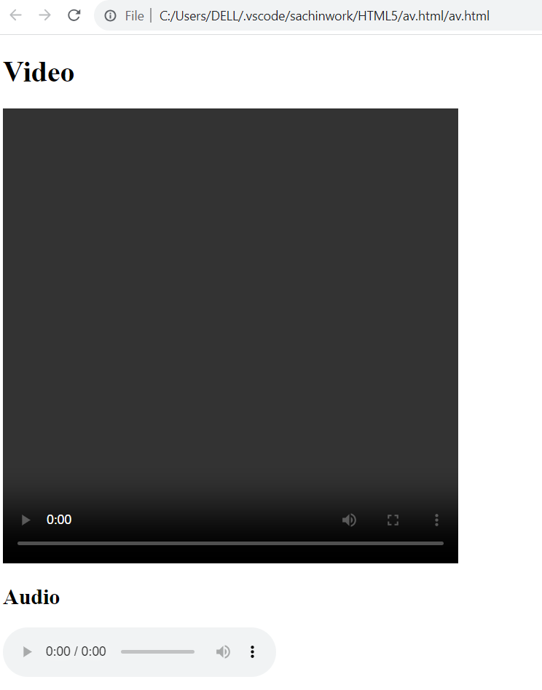

**3. Semantic element in HTML5?**

* A semantic element clearly describe its meaning.

**Ex:-**

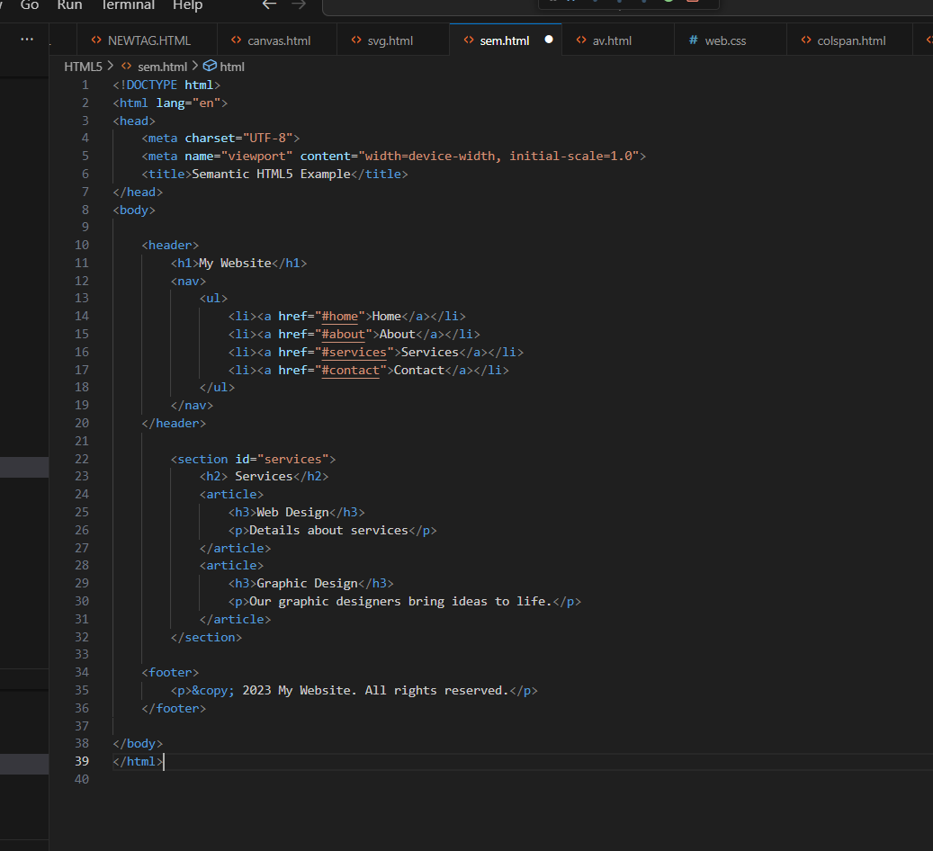

Output:-

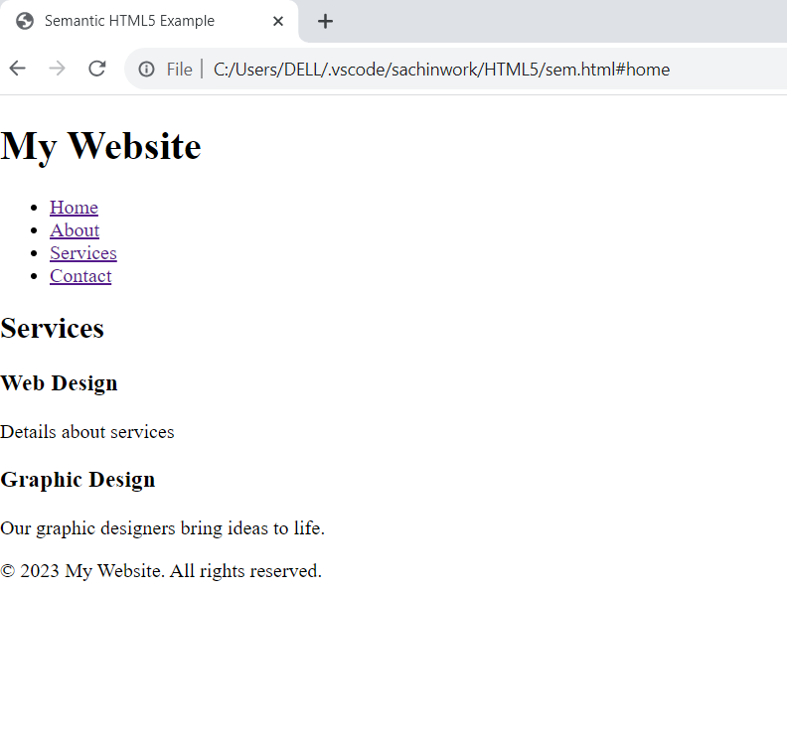

**4. canvas and svg tags**

1.Canvas

* The Html <canvas> elements is used to draw graphics on web page.
* The <canvas> elements is only a container for graphics.

**Ex:-**

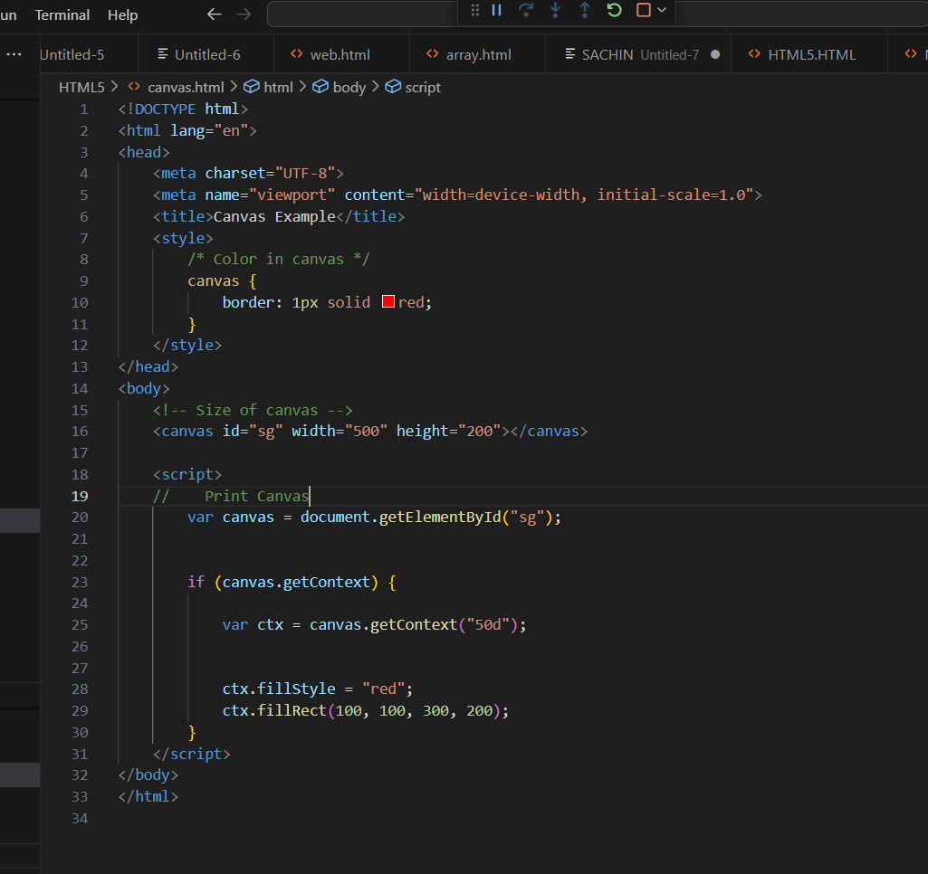

**Output:-**

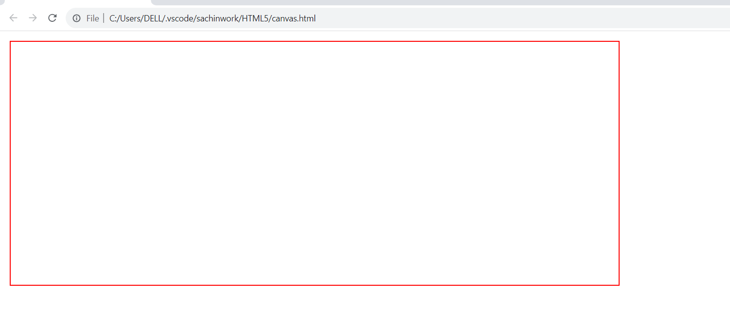

2.SVG

* The html <svg> elements is a container for svg graphics..

**Ex:-**

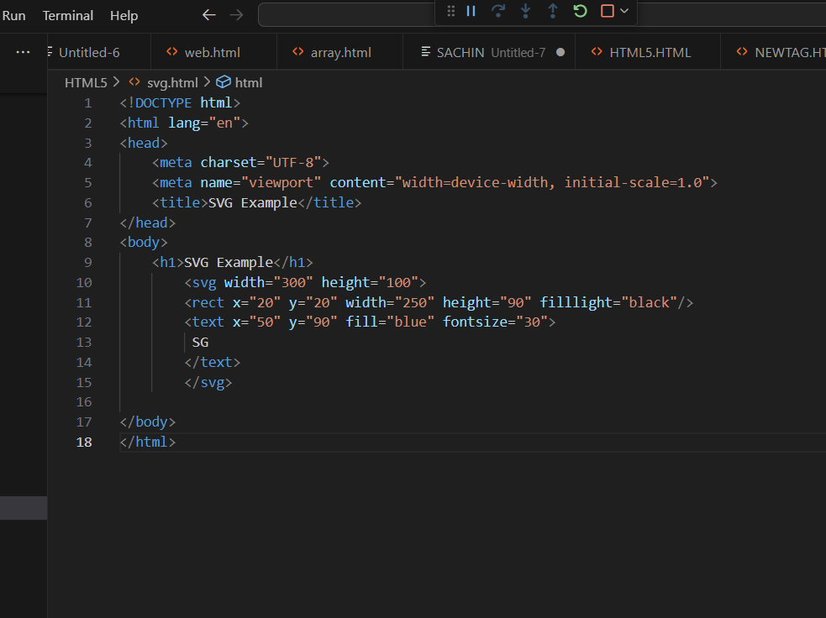

**Output:-**

